ME-Mesopotamia- Goddess of water with a water jug-2900-1759 BCE

Terracotta votive statuette of Ninhursag, 180.4 mm. (7.1 in.) high and weighs 4504.2 gm. (9.93 oz.). She is depicted wearing a horned head-dress and a full-length skirt. Her top is a net-like bodice.

Ninhursag's name is derived from NIN 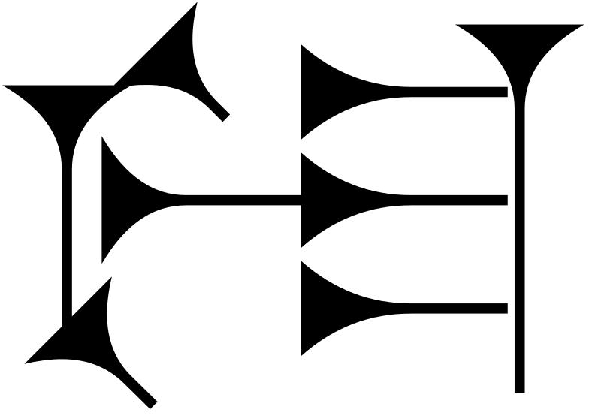 (queen , priestess, "lady") + ḪUR/ ḪAR (mountain) + SAG (head, top) (mountain top) 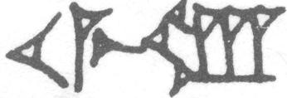, hence "lady of the mountain-top," where the water originates, one of the seven great deities of Sumer (*Šumeru*, Akkadian*;* [*ki*](http://en.wikipedia.org/wiki/Ki_(earth))*-*[*en*](http://en.wikipedia.org/wiki/EN_(cuneiform))*-ĝir,* Sumerian) in southern Mesopotamia, modern Iraq (Labat and Malbran-Labat 1988: nos. 556, 401; cf. Dalley 1998: 326). Temple hymn sources identify her as the "lady who gave birth" and kings of Sumer were depicted as being "constantly nourished with milk by Ninhursag" (Kramer 1963:115-122).

SHAPE \* MERGEFORMAT 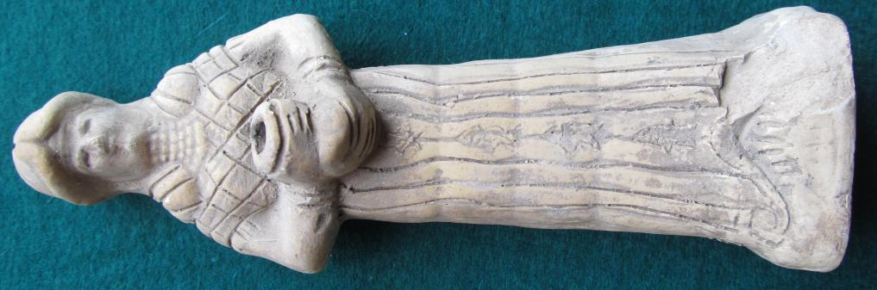 SHAPE \* MERGEFORMAT 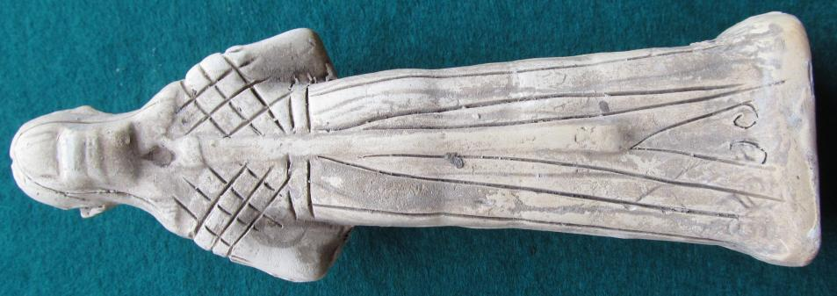 SHAPE \* MERGEFORMAT 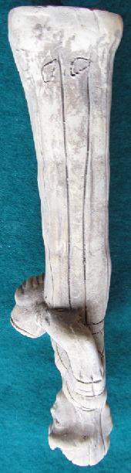 SHAPE \* MERGEFORMAT 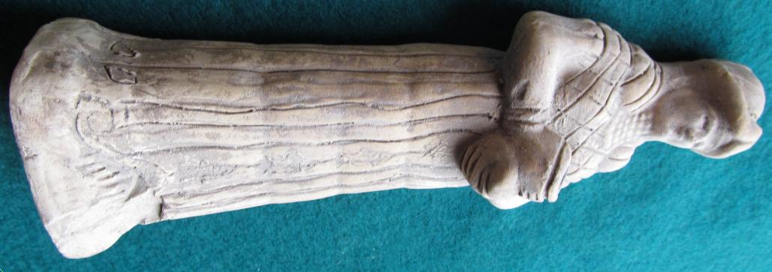

Figs. 1-4.

The original stone statue from which this terracotta votive statuette has been modeled was excavated in northern Mesopotamia at modern Tell Hariri (ancient Mari), Syria, and is dated to the early Archaic Period, 2900-1759 BCE. The original statue, which was human-sized, depicted Ninhursag holding a water jug in both hands: as water was channeled through her body it flowed from the water jug (which is indicated by the wavy lines down her front) acting as a symbolic fountain in the center of Mari's palace complex (See Fig. 5).

In this terracotta votive statuette of Ninhursag, she is wearing a full-length skirt which is a vestment (*pala* ; Halloran 2012 )denoting deities or rulers that has four fibula-like fasteners in the form of fish fastening the front of her dress, at the bottom of which is her traditional symbol, an omega-like motif, **Ω**, (See Fig. 5) that also appears on some boundary stones indicating places of her cultic worship. She probably wears wig, which was used as a symbol of Ninhursag (Van Buren 1930: 19), on top of which is a horned headdress (with only one set of horns) called a *shugurra.*  At the nape of her neck is a rectangular container, perhaps a *ñadub* (Halloran 2012 )for holding sacred tablets relating to her worship, which is fastened to the *shugurra*, from which depends two strands that form a body-length tassel. The tablets would contain texts such as those relating to her role as sustainer as in the so-called "Liturgy to Nintud": "The house of Ninkharsag [Ninhursag] is the life of the land; for [from] its land there is food (Barton 1918: 64). An artist's reconstructed view of ancient Mari's canals (Fig. 8) reflects in the town's architecture the centrality of the theme of Ninhursag's role in bringing water to the town's canals. Color imagery also reinforces her role as a water deity, since she wears a six-layered necklace, probably of lapis-lazuli the color of which symbolizes the clear blue water she brings to the people (see George 2003: 891) , which is suggested by the reference to "the lapis lazuli (beads) around my neck". Her net-like bodice may also relate to the water theme since it may signify the important role that fishing with nets in the Euphrates had for the people's nutrition and this imagery would be in keeping with the fish-image fibulae on the front of her *pala* where they are depicted swimming up-stream to her water-spouting jug .

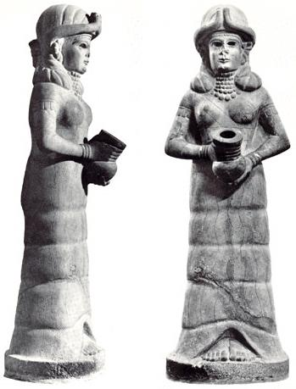

Fig. 6. The human-sized white stone statue of Ninhursag (*mama* in Akkadian) in the guise of the goddess of irrigation, found at Mari on the upper Euphrates in Syria on display in the National Museum, Aleppo, Syria.

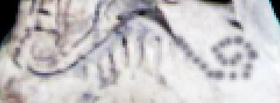

Fig. 5. Reconstructed omega-like motif, **Ω**, on the base of the terracotta Ninhursag.

Fig. 8. Artist's view of a reconstructed Mari (Tell Hariri, Syria), 2900-1759 BCE, showing the extent of its domain and its canal system. From: http://upload.wikimedia.org/wikipedia/commons/thumb/a/a3/The_ancient_city_of_Mari.jpg/285px-The_ancient_city_of_Mari.jpg

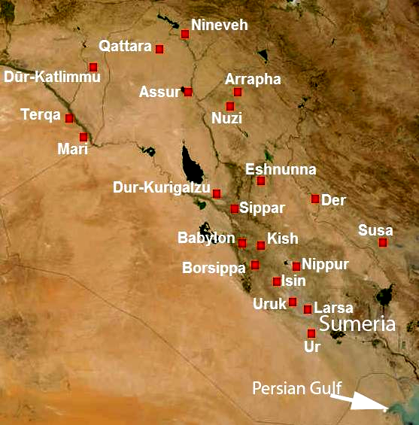

Fig. 7. Map showing Mari (Tell Hariri, Syria), 2900-1759 BCE and and its relative distances from related second millennium BCE archaeological sites.

After http://upload.wikimedia.org/wikipedia/commons/f/fa/Meso2mil-English.JPG

References

Barton, George A. 1918. *Miscellaneous Babylonian Inscriptions*. New Haven: Yale University Press.

Dalley, Stephanie. 1998. *Myths from Mesopotamia: Creation, the Flood, Gilgamesh, and Others*. New York: Oxford University Press.

George, A.R. 2003. *The Babylonian Gilgamesh Epic: introduction, critical edition and cuneiform texts*. Oxford: Oxford University Press.

Halloran, John A. 2012. *Sumerian Lexicon*. Version 3.0. http://www.sumerian.org/sumerlex.htm

Kramer, Samuel Noah. 1963. *The Sumerians: their history, culture and character.* Chicago: University of Chicago Press.

Labat, René, Malbran-Labat, Florence. 1988. *Manuel d'Epigraphie Akkandienne: signes, syllabaire, indéogrammes*. 6th ed. Paris: Librarie Orientaliste Paul Guenther.

Van Buren, Elizabeth Douglas. 1930. *Clay figurines of Babylonia and Assyria*. New Haven: Yale University Press; London: Oxford University Press, H. Milford.